DUNDALK INSTITUTE OF TECHNOLOGY
BSc (Hons) in Computing Systems and Operations - Semester 2

Networking

Practical Exam 2025
Frances Byrne
Date
Time
Answer ALL questions
Instructions
Answers (text and screenshots) to specific questions should be added to a word document and uploaded to Moodle along with the Packet Tracer file.

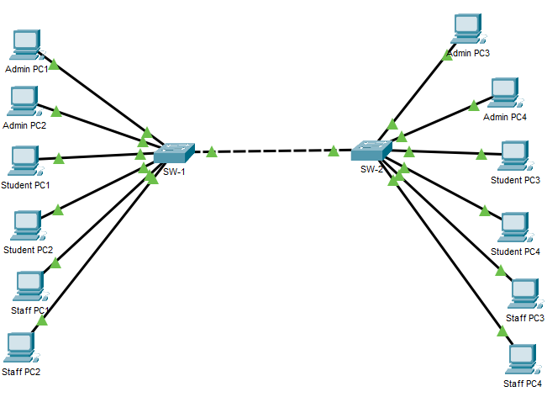
Figure 1 Practical Exam Topology

- Build the topology shown in Figure 1 using Packet Tracer.
Note
- The switches should be 2960 series switches.
- Connect the PC’s to the switch ports identified in Table 1 and Table 2.
- Connect the switches using port GigabitEthernet0/1 on both switches.
(10 marks)

- Assign the IP configuration shown in Table 1 and Table 2 to each PC.
(12 marks)

Devices connected to SW-1
Device | Switch port | VLAN | IP Address | Subnet Mask
Admin PC1 | FastEthernet0/1 | 200 | 192.168.200.1 | 255.255.255.0
Admin PC2 | FastEthernet0/2 | 200 | 192.168.200.2 | 255.255.255.0
Student PC1 | FastEthernet0/3 | 201 | 192.168.201.1 | 255.255.255.0
Student PC2 | FastEthernet0/4 | 201 | 192.168.201.2 | 255.255.255.0
Staff PC1 | FastEthernet0/5 | 202 | 192.168.202.1 | 255.255.255.0
Staff PC2 | FastEthernet0/6 | 202 | 192.168.202.2 | 255.255.255.0
Table 1 Configuration information for PC's connected to SW-1

Devices connected to SW-2
Device | Switch port | VLAN | IP Address | Subnet Mask
Admin PC3 | FastEthernet0/1 | 200 | 192.168.200.3 | 255.255.255.0
Admin PC4 | FastEthernet0/2 | 200 | 192.168.200.4 | 255.255.255.0
Student PC3 | FastEthernet0/3 | 201 | 192.168.201.3 | 255.255.255.0
Student PC4 | FastEthernet0/4 | 201 | 192.168.201.4 | 255.255.255.0
Staff PC3 | FastEthernet0/5 | 202 | 192.168.202.3 | 255.255.255.0
Staff PC4 | FastEthernet0/6 | 202 | 192.168.202.4 | 255.255.255.0
Table 2 Configuration information for PC's connected to SW-2

- Configure the following on the switch SW-1
    - Hostname (SW-1)
(2 marks)
    - Privileged Secret (class)
(2 marks)
    - Console password (cisco)
(2 marks)
    - VTY password (letmein)
(2 marks)
    - Encrypt all passwords.
(2 marks)
    - Create a MOTD banner stating that unauthorised access is prohibited.
(2 marks)
    - Assign the IP address 192.168.1.254 and subnet mask 255.255.255.0 to SW-1 using VLAN 1.
(4 marks)
- Add a screenshot to this document showing where the Console password is required.
(4 marks)
- Configure the following on the switch SW-2
    - Hostname (SW-2)
(2 marks)
    - Assign the IP address 192.168.1.253 and subnet mask 255.255.255.0 to SW-2 using VLAN 1.
(4 marks)

- Add a screenshot to this document showing a ping from SW-1 to SW-2.
(4 marks)

- Configure the 3 VLANs shown in Table 3 on BOTH SW-1 and SW-2
(12 marks)

VLAN ID | VLAN Name
200 | Admin
201 | Student
202 | Staff
Table 3 VLAN details

- Assign ports to the appropriate VLAN as specified in Table 1 and Table 2.
(12 marks)

- Configure GigabitEthernet0/1 on both SW-1 and SW-2 to permit all VLAN traffic.
(6 marks)

- Using simple PDU’s, determine which of the following tests are successful.

Test | Successful | Failed
Staff PC1 → Staff PC4 | ✅
Staff PC2 → Student PC2 |  | ✅
Staff PC3 → SW-2 |  | ✅
Admin PC1 → Admin PC2 | ✅
Admin PC1 → Admin PC3 | ✅
Admin PC1 → Staff PC2 |  | ✅

(6 marks)
- Take a screenshot of the ARP table on Admin PC1 and add it to this document.
(4 marks)

- Indicate why some of the tests in part 10 were not successful.
(6 marks)
- Save the configuration on both SW-1 and SW-2.
(2 marks)

Save this file and the Packet Tracer file. Upload both files to Moodle using the Upload Completed Practical Exam assignment upload facility.

